THE MIRACLE CLEMENTINE OF 18 MAY 2015
THE EXCLUSIVE ISLAMIC MIRACLE PHOTOGRAPHS OF DR UMAR ELAHI AZAM
MANCHESTER, UK

CLEMENTINES BOUGHT FROM: AVA FRUIT AND VEG STORE, YARBURGH STREET, WHALLEY RANGE, MANCHESTER M16 7FJ
DATE THEY WERE BOUGHT: c. FRIDAY 15 MAY 2015

THE FOUR PHOTOGRAPHS BELOW ARE OF THE SAME CLEMENTINE

Please scroll down to the next page for the first photograph
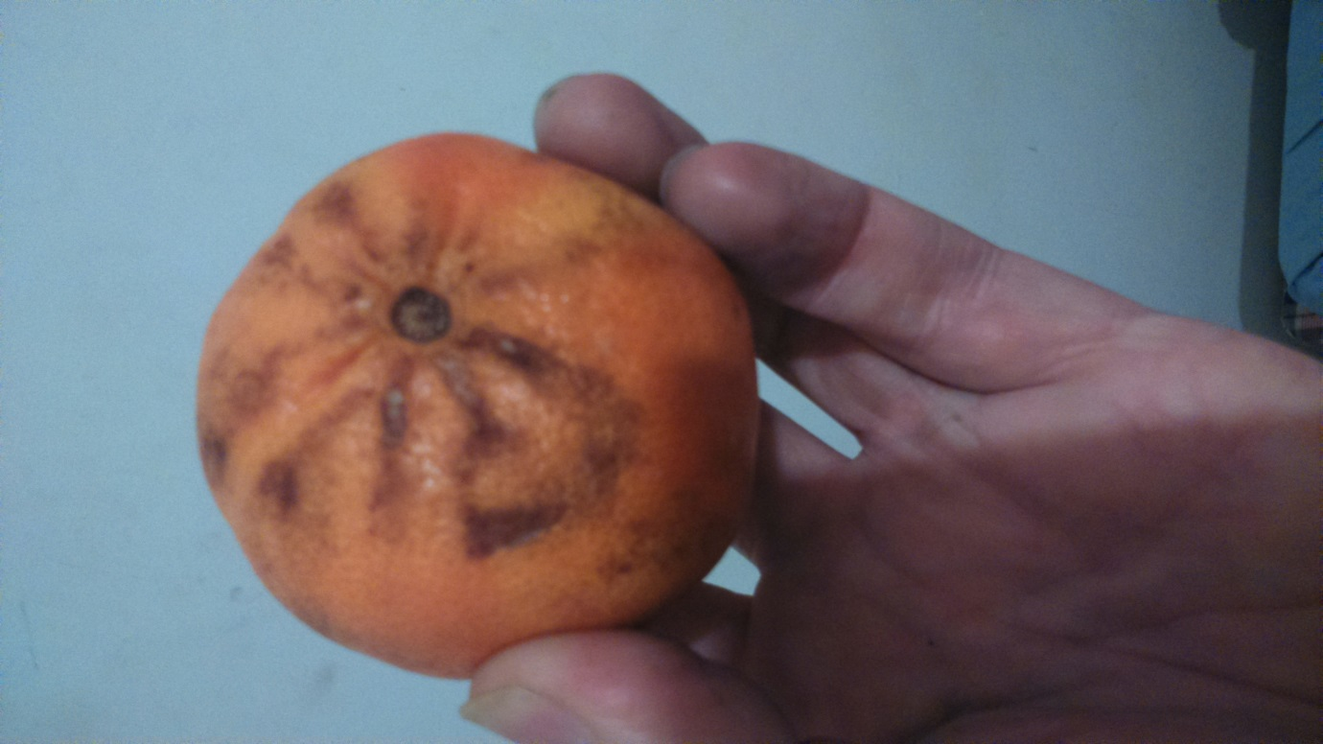

This was the general shape on part of the surface of the clementine

Please scroll down to the next page for the first photograph
The Name of Allah Most High can clearly be made out in this picture-effect fire-glow photograph:
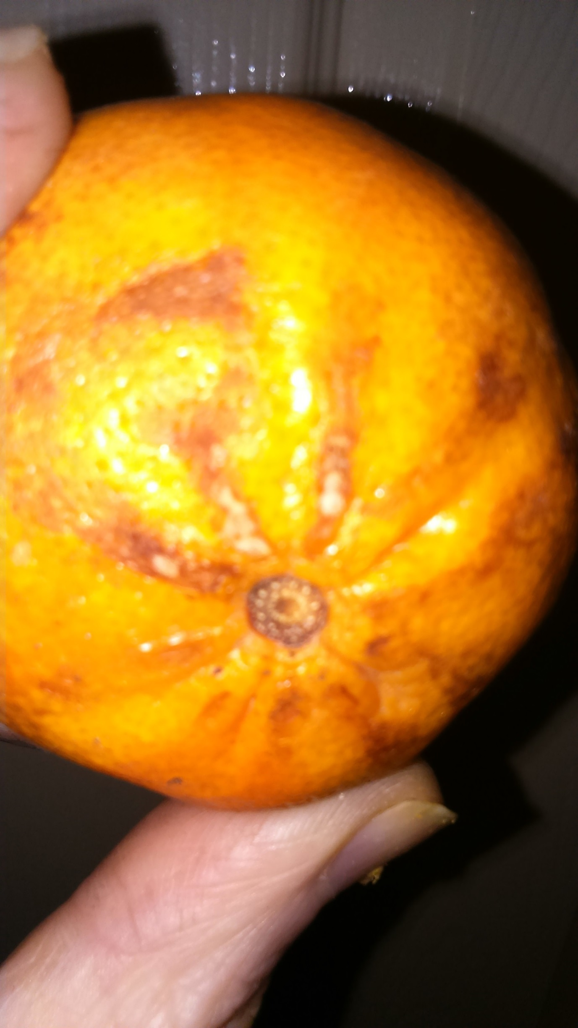
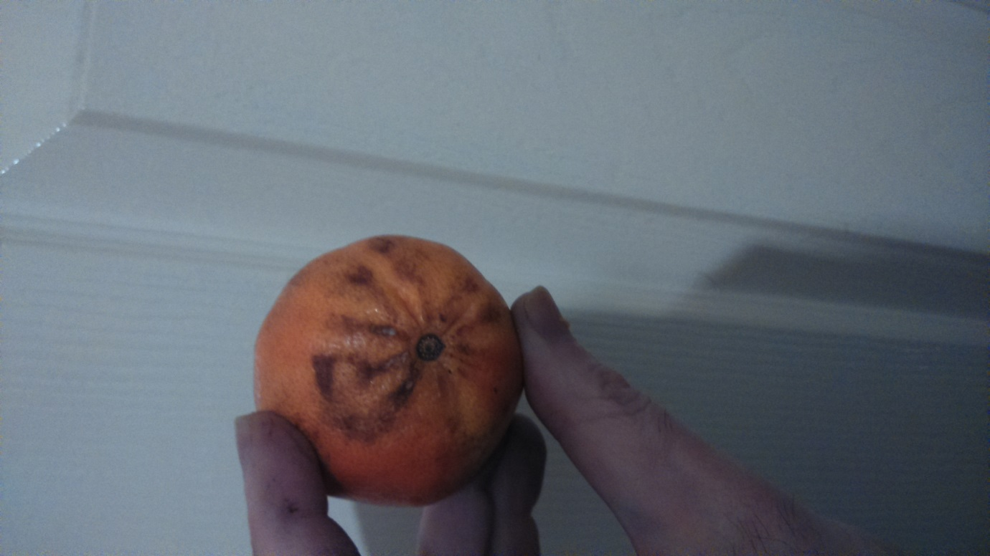
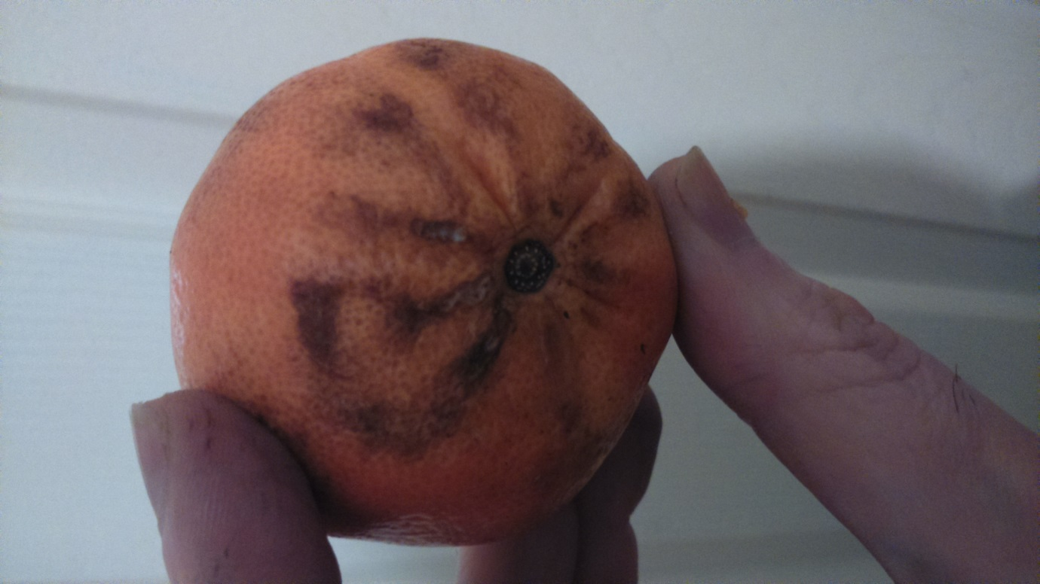

What can also be seen from these photographs is that the Arabic letter ‘Ha’ from the Arabic letters for Allah -
is like a love-heart shape!
The ‘Ha’ can be joined too, as in the image below:
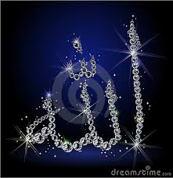
and it is joined on the fruit, but like a love heart.

