WHO'S WHO NOMINATION
Date: | Tue, 13 Dec 2005 11:04:15 -0500 (EST)
From: | "Kane at InternetSeer Support" <email@mail.internetseer.com>
To: | dr_umar_azam@yahoo.co.uk
Subject: | Who's Who Nomination

Dear Dr Azam,
On behalf of International WHO'S WHO of Professionals, I am pleased to inform you that you have been nominated as a ca ndidate for inclusion in the 2005-2006 ed ition. We congratulate you. Nomi nation to WHO'S WHO is an honor in itself. WHO'S WHO has over 20,000 m embers in 154 countries. It is the most elite professional network in the world. The members assist each other daily with business and career opportunities. It is in tim es like these that such a network is most valuable and we are seeing members help othe r members expand their businesses, find new positions, even relocate to another country. If selected into WHO'S WHO, you will also be listed in the 2006-2007 edition of Inte rnational WHO'S WHO of Professionals. This is the definitive work on the world's leade rs in commerce, economics, policy, and trade. We do require additional information to complete the selection process and ask that you provide your biographical data by accessi ng the form on our website at:http://www.internationalwhoswho.com/Nominations/FE1651C.aspx. Our editorial deadline is quickly approaching. I urge you to act today. If you delay, I cannot guarantee the committee will have ample time to review your submission. Sincerely, Wayne Ue hara Publications Director 2020 Pennsylvania Ave. N.W., PMB #504 Washington, D.C. 20 006 P.S. There is no cost or obligation to be listed in the International WHO'S WHO of Professionals. To ensure your biographical data is received in time, please complete th e online form http://www.internationalwhoswho.com/Nominations/FE1651C.aspx by January 6 , 2005. Upon review, our Membership Selection Committee will be in touch with you. Mem bers of our Board of Advisors include: Wallid Abdo, CEO, Eurobrokers-Greece; Michael Gondi ve, CEO, Eastern and Southern African Trade and Development Bank-Kenya; Fehmi Sami, Senior VP, Citibank, N.A.-Great Britain; Yusuf Alami, C OO, Abdu Dhabi Investment Company-UAE; Mikhail Zaitsev, Finance Director, Volvo Car-Russia; DR. Jung Kook Paeng, CIO, Hyundai Motor Company, Korea; John Sai Chi Mak, Managing Directo r, Bulova Watch International, Ltd.-Hong Kong; and Aldo Castelli, President, Shell Brasil , Ltda.-Brazil
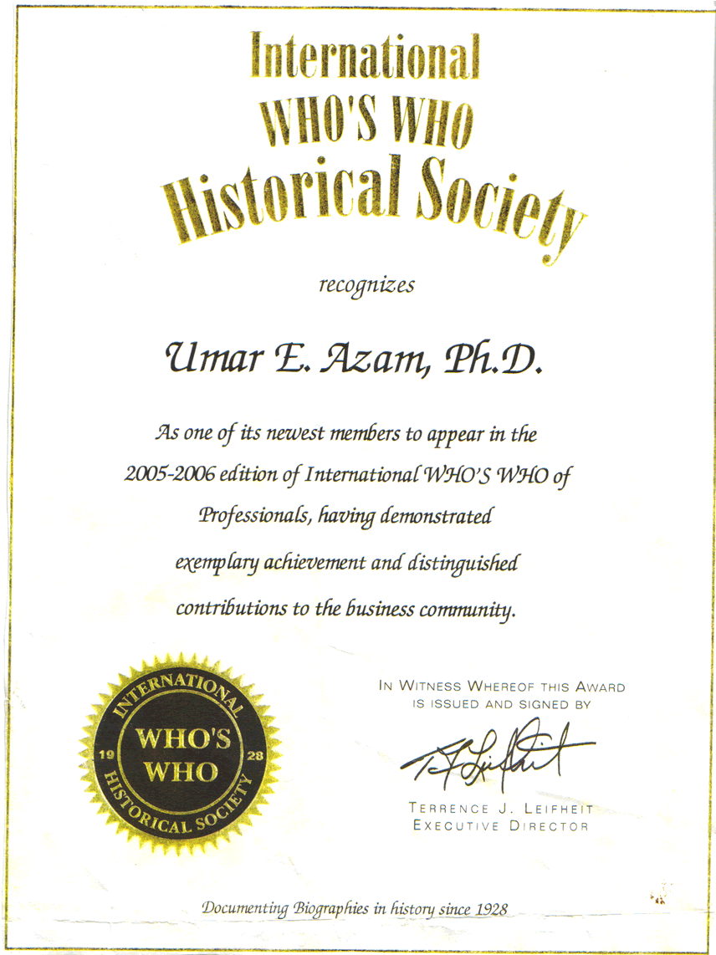

INDEX OF KEY INFORMATION

1. PRACTICAL ISLAMIC ADVICE

p.1O : PRAYER FOR EASY JUDGEMENT; SUPPLICATION TO ALLAH; PRAYER FOR SALVATION; DAROOD TO SEE THE HOLY PROPHET [PBUH] IN A DREAM.

p. 11 : VERSES CONTAINING THE 'GREAT NAME', THE ISM-E-AZAM.

p.12 : PRAYER FOR FACE TO BE SHINING LIKE THE FULL MOON; PRAYER FOR 2,000,000 GOOD DEEDS; PRAYER FOR AVOIDING HELL; PRAYER TO REMOVE 99 EVILS FROM ONESELF.

p.13 : DESCRIPTION OF PARADISE AND HELL.

p.17 : NUMERICAL TAWEEZ OF SURAH AR-RAHMAN, SURA WAQEA, SURAH JINN, SURAH MUZZAMMIL, SURAH AL-MULK, SURAH NOAH, SURAH KAHF, SURAH YA SIN.

p. 18 : PRAYER FOR 1,000 GOOD DEEDS; PRAYER FOR RANK BEING RAISED BY 1,000 DEGREES IN PARADISE; PRAYER FOR HAVING 70,000 ANGELS TO PRAY FOR YOUR FORGIVENESS UNTIL THE DAY OF JUDGEMENT.

p.19 : PRAYER FOR THE REWARD OF THE STATUS OF A MARTYR.

p.21 : PRAYER FOR THE BESTOWAL OF TEN GRACES FROM ALLAH MOST HIGH.

p.22 : PRAYER FOR FORGIVENESS; PRAYER TO BE RECITED BEFORE RETIRING TO BED.

p.23 : PRAYER FOR THE INTERCESSION OF THE PROPHET [PBUH] ON THE DAY OF JUDGEMENT.

p.24 : PRAYER TO SEE YOUR HOUSE IN PARADISE.

p.27 : THE 99 NAMES OF ALLAH.

p.29 : ARABIC TAWEEZ : TO END WITCHCRAFT; TO KEEP AWAY FROM ALCOHOL AND DRUGS.

p.30 : ARABIC TAWEEZ : FOR LOVE; INCREASE IN WEALTH.

p.31 : ARABIC TAWEEZ : FOR EXPELLING JINN; FOR SUCCESS IN ANY DIFFICULT TASK; FOR RECOVERY FROM AN ILLNESS.

p.32 : ARABIC TAWEEZ : FOR SUCCESS IN LIVELIHOOD; FOR DIFFICULTIES IN EMPLOYMENT; FOR SUCCESS IN LOVE.

p.33 : ARABIC TAWEEZ : FOR SUCCESS OF SHOP BUSINESS; FOR SUCCESS IN CAREER; FOR SUCCESS IN [ANY] EMPLOYMENT.

p.34 : ARABIC TAWEEZ : FOR EASE IN CHILDBIRTH; SAFETY FROM CALAMITIES; SUSTENANCE.

p.35 : ARABIC TAWEEZ : REMEDY FOR SUGAR DIABETES; REMEDY FOR BLOOD PRESSURE; KEY TO ALL SUCCESS.

p.36 : ARABIC TAWEEZ: REMEDY FOR DEPRESSION OR DIFFICULTY; TO KEEP AWAY FROM QUARRELS AND FIGHTS; FOR SUCCESS IN EXAMS.

p.39 : DESCRIPTION OF PARADISE

p.40 : WHAT THERE WILL BE IN PARADISE.

p.41 : WHAT THE EIGHT GATES OF PARADISE LOOK LIKE.

p.42: PLEASE FILL IN THIS SURVEY FORM FOR PRACTICAL ISLAMIC ADVICE.

2. ASPECTS OF ISLAM

PHOTO NO. 1 : TREE SHAPED AS A PERSON DOING RUKU.

PHOTO NO. 2 : SURAHS OF THE HOLY QURAN AND THE NAME OF ALLAH MOST HIGH.

PHOTO NO. 3 : THE FIRST KALIMAH WRITTEN IN EVERY HUMAN'S LUNGS.

PHOTO NO. 4 : MENTION OF 'RED ROSE' NEBULA IN THE HOLY QURAN 1400 YEARS AGO.

PHOTO NO. 5 : GERMAN FOREST FORMING THE FIRST KALIMAH.

PHOTO NO. 6 : FISH FOUND WITH ARABIC WRITING ON IT.

PHOTO NO. 7 : MOSQUE SURVIVES EARTHQUAKE!

PHOTO NO. 8 : HONEY COMB FORMING 'ALLAH'.

PHOTO NO. 9 : STONE WITH ALLAH'S NAME ON IT.

PHOTO NO 10 : EGGS WITH ALLAH'S NAME ON THEM.

PHOTO NO. 11 : CLOUD FORMING ALLAH'S NAME.

PHOTO NO. 12 : 'ALLAH' WRITTEN ON A TOMATO.

PHOTO NO. 13 : RELIGIOUS VERSES WRITTEN ON FISH [JAVANESE MARKINGS].

PHOTO NO. 14 : 'ALLAH' WRITTEN ON A WATER MELON.

PHOTO NO. 15 : 'ALLAH' WRITTEN ON AN EGG PLANT [AUBERGINE].

PHOTO NO. 16 : EVERYONE'S RIGHT HAND FORMS THE NAME OF 'ALLAH'.

PHOTO NO. 17 : 'ALLAH' FORMED IN BABY'S EAR.

PHOTO NO. 18 : 'ALLAH' WRITTEN IN THE OCEANS.

PHOTO NO 19 : 'ALLAH' WRITTEN IN A BEAN.

SEE THE FOLLOWING LINK FOR GALLERIES OF PHOTOGRAPHS OF ISLAMIC MIRACLES, PHOTOS YOU HAVE NOT SEEN BEFORE:

http://www.geocities.com/islamimiracles/islamic_miracles1.htm

3. DREAMS IN ISLAM

SECTION 2: NOTES

POINT NO. 96: DAROOD SHARIF FOR THE INTERCESSION OF THE HOLY PROPHET [PBUH] ON THE DAY OF JUDGEMENT.

POINT NO. 98: DAROOD SHARIF FOR FORGIVENESS AND ACQUIRING THE HIGHEST GRADE IN PARADISE.

4. THE BRITISH MUSLIMS

CHAPTER 1

A] VERSES FROM THE HOLY QURAN DESCRIBING ALLAH'S ATTRIBUTES.

B] THE 99 NAMES OF ALLAH

C] DESCRIPTION OF ALLAH IN HADITH.

CHAPTER 2

A] THE FIVE PILLARS OF ISLAM

B] QURANIC VERSES REGARDING: DRESS, DIET, MARRIAGE, PARENTHOOD AND KNOWLEDGE.

C] HADITH ON THE MERIT OF GIRLS DOING HOUSEWORK.

CHAPTER 3

A] DIAGRAM OF THE HEREAFTER.

B] THE NATURE OF PARADISE.

C] HADITH: THE VISION OF GOD IN PARADISE.

5. PALESTINE

'PRACTICAL HELP' SECTION

LIST OF CHARITIES IN THE UNITED KINGDOM WHICH HELP TO FEED, CLOTHE PALESTINIAN FAMILIES. [YOUR HELP IS VITAL!]

6. COMPETITIONS

'COMPETITIONS' LINK/ END SECTION OF 'ISLAM AND THE YOUNGER GENERATION' LINK

ENTER AN ISLAMIC COMPETITION [ALL AGES] AND WIN A CERTIFICATE AND PRIZE!

